Selection sort algorithm walkthrough with barrel weight example
Wed, 22 Apr 26
Selection Sort Overview
- Easiest sorting method for arranging elements
- Core principle: select minimum element and place in appropriate position
- Works by repeatedly finding smallest remaining element
Algorithm Process
- Step-by-step approach using barrel weight example:
  - Select minimum weight barrel (2kg) → move to leftmost position
  - Find next minimum (3kg) → place in second position
  - Continue pattern (5kg → third position)
  - Repeat for remaining elements (6kg, 8kg)
  - Final element (9kg) already in correct position
Key Characteristics
- Progressively builds sorted portion from left to right
- Each step places one element in final position
- Remaining unsorted elements decrease with each iteration
- Uses swapping to position elements correctly
Next Steps
- Formal algorithm discussion scheduled for following video
- Will cover technical implementation details

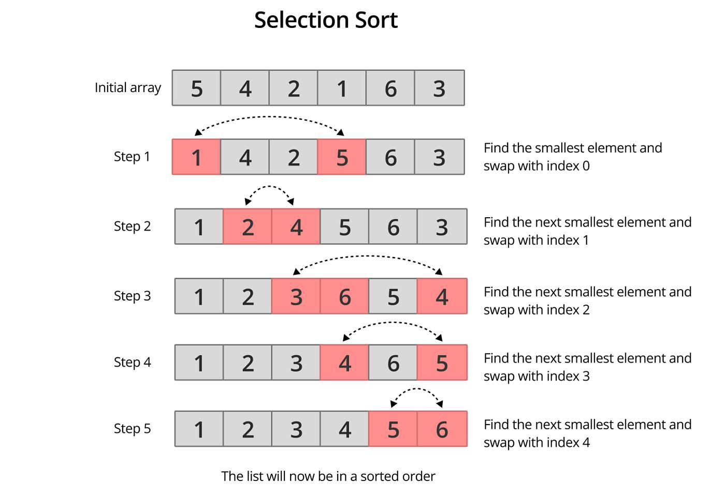

- Each barrel = an element in the array
- Weight = value
- Goal = arrange barrels from lightest → heaviest
- Strategy:
  - Find the lightest barrel
  - Swap it with the first unsorted position
  - Repeat for remaining barrels

🔄 Step-by-Step Example
Let’s say we have barrels with weights:
[64, 25, 12, 22, 11]
Pass 1:
- Find smallest → 11
- Swap with first element
[11, 25, 12, 22, 64]

Pass 2:
- Remaining: [25, 12, 22, 64]
- Smallest → 12
- Swap with second position
[11, 12, 25, 22, 64]

Pass 3:
- Remaining: [25, 22, 64]
- Smallest → 22
[11, 12, 22, 25, 64]

Pass 4:
- Remaining: [25, 64]
- Smallest → 25
[11, 12, 22, 25, 64]
✔ Sorted!

🧾 C# Code (Selection Sort)
using System;

class SelectionSortExample
{
static void SelectionSort(int[] arr)
{
int n = arr.Length;

for (int i = 0; i < n - 1; i++)
{
int minIndex = i;

for (int j = i + 1; j < n; j++)
{
if (arr[j] < arr[minIndex])
{
minIndex = j;
}
}

// Swap
int temp = arr[minIndex];
arr[minIndex] = arr[i];
arr[i] = temp;
}
}

static void Main()
{
int[] weights = { 64, 25, 12, 22, 11 };

SelectionSort(weights);

Console.WriteLine("Sorted Weights:");
foreach (int w in weights)
{
Console.Write(w + " ");
}
}
}

📊 Time & Space Complexity
Time Complexity
T(n)=\frac{n(n-1)}{2}=O(n^2)
- Always O(n²) (no best-case optimization)
- Because we always scan the remaining barrels fully
Space Complexity
- O(1) → No extra space (in-place sorting)

⚖️ Key Insight (Barrel Thinking)
- You don’t move all barrels repeatedly
- You only pick the minimum each time
- That’s why:
  - Fewer swaps than bubble sort
  - But still slow for large datasets

If you want, I can convert this into:
- Animated step-by-step diagrams
- Comparison with Bubble / Insertion using same barrel analogy
- Or a real visualization tool you can run in your .NET app
Selection sort algorithm complexity and implementation overview
Wed, 22 Apr 26
Selection Sort Algorithm Overview
- Takes array and length as parameters
- Uses n-1 rounds to sort n elements
- Each round selects position and finds smallest remaining element
- Algorithm structure:
  - Outer loop: for i = 0 to n-1 (rounds)
  - Position variable initialized to i
  - Inner loop: for j = i+1 to n (find minimum)
  - Swap smallest element with element at position i
Algorithm Implementation Details
- Position tracking:
  - Variable “position” stores index of current smallest element
  - Starts at i for each round
  - Updates when smaller element found
- Comparison process:
  - if a[j] < a[position], update position = j
  - Continues through entire remaining array
- Swapping mechanism:
  - temp = a[i]
  - a[i] = a[position]
  - a[position] = temp
Stability Analysis
- Selection sort is unstable algorithm
- Example with duplicate element 5:
  - Original order: yellow 5, white 5
  - After sorting: relative order changes
  - Yellow 5 moves after white 5
- Loses relative ordering of equal elements
Time Complexity Analysis
- Comparisons per round:
  - Round 1: 5 comparisons
  - Round 2: 4 comparisons
  - Round 3: 3 comparisons
  - Pattern: (n-1) + (n-2) + … + 1 = n(n-1)/2
  - Time complexity: O(n²)
- Swaps per round:
  - Exactly 1 swap per round
  - Total: n-1 swaps
  - Swap complexity: O(n)
- Key characteristics:
  - Minimum number of element movements among sorting algorithms
  - Always O(n²) time regardless of input order (even if already sorted)
  - Must always search for minimum in remaining elements
Algorithm of Code Explanation
Alright—let’s break the C# Selection Sort code using the same weight barrel visualization, so every line of code maps to something physical and intuitive.

🎯 Idea Recap (Barrels = Array Elements)
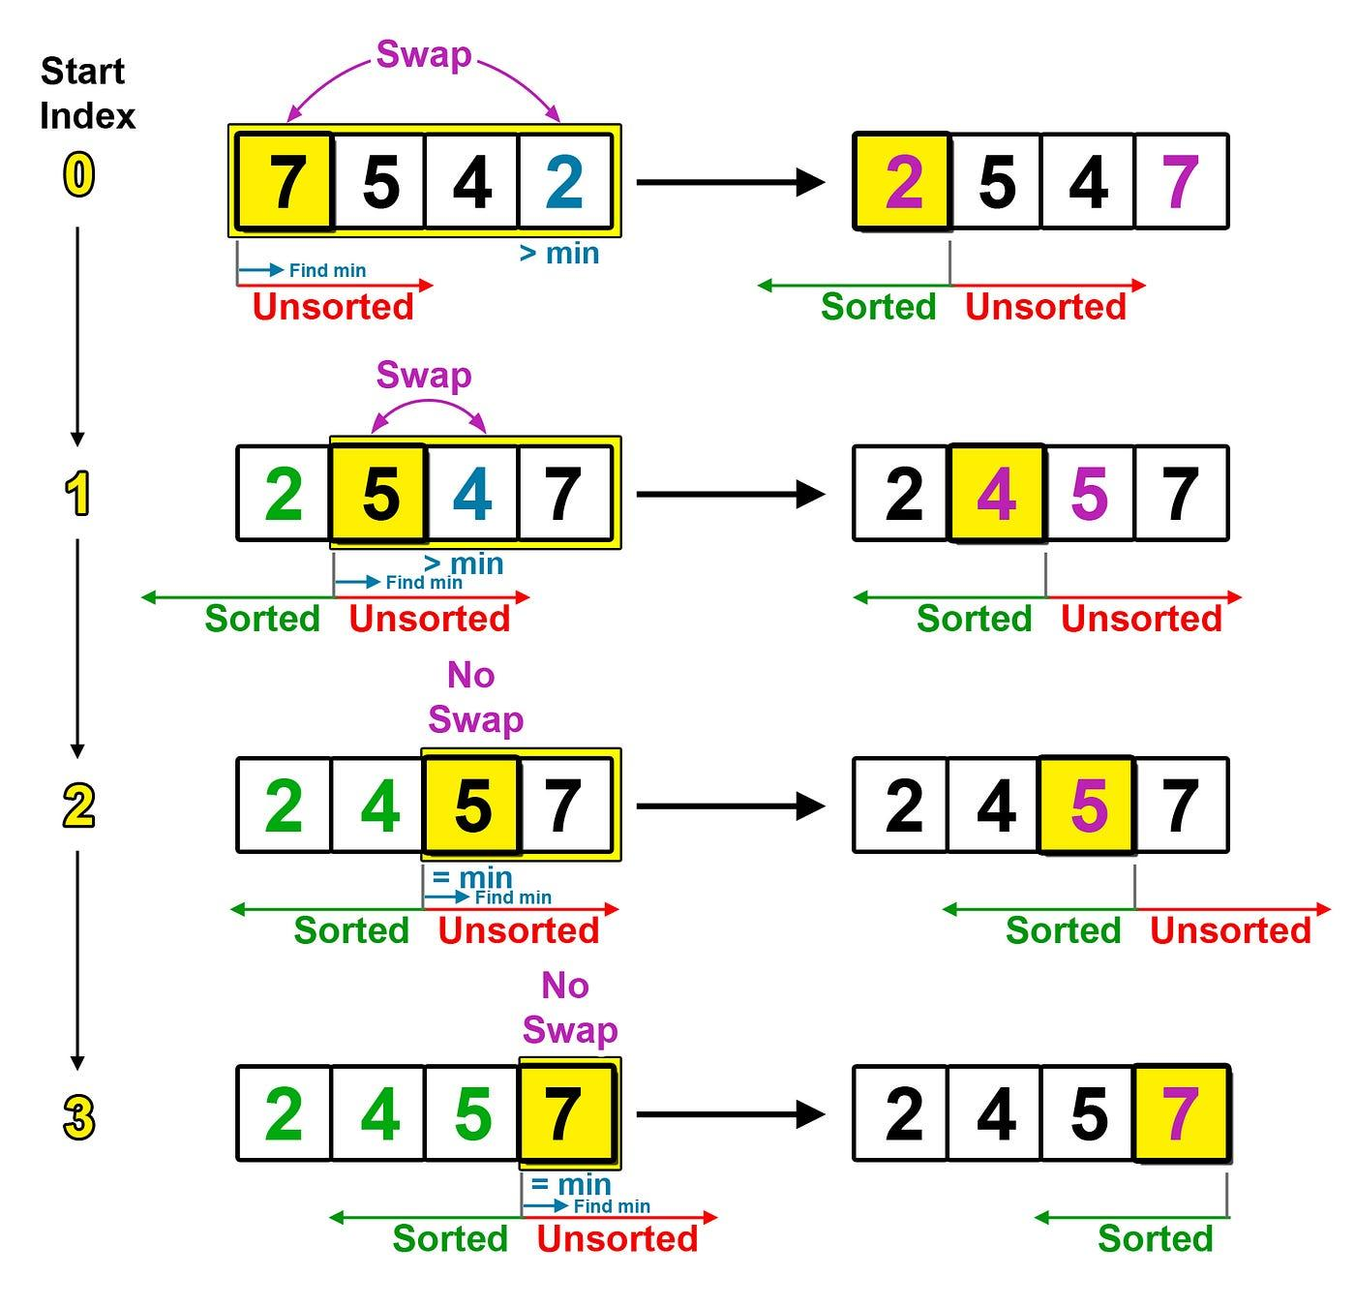
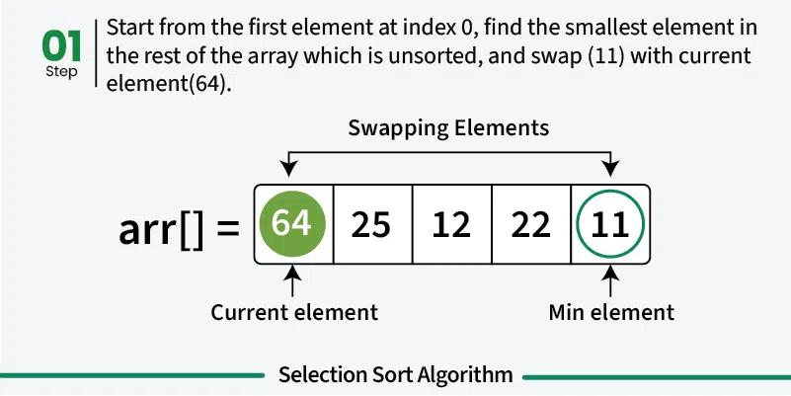
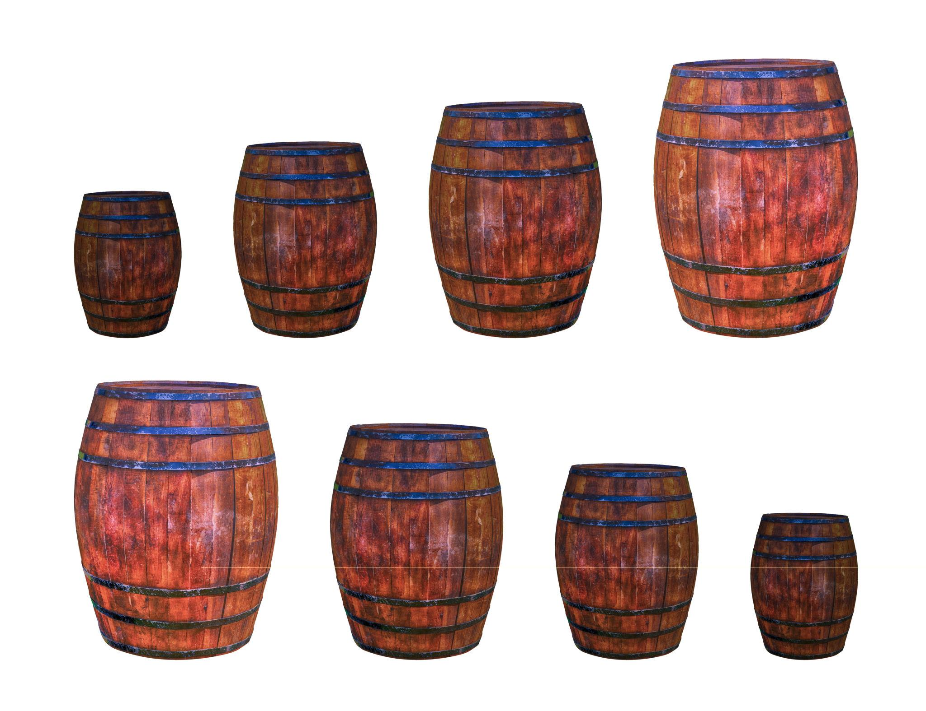
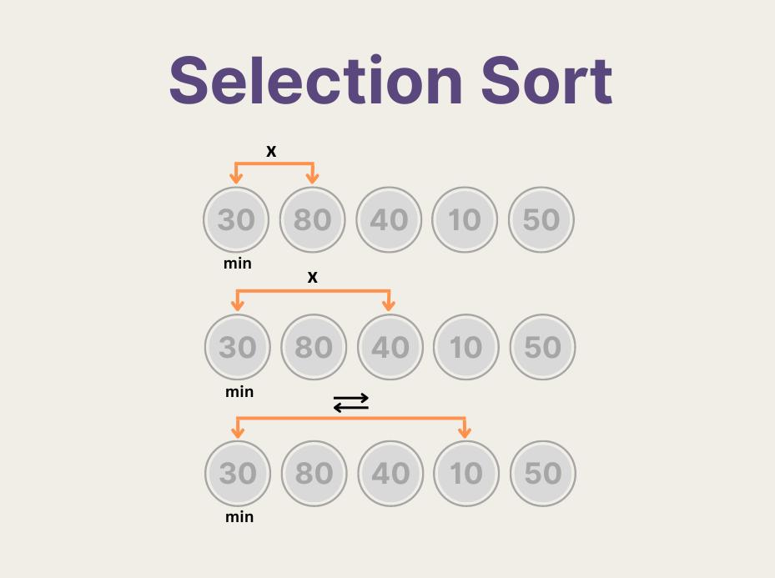

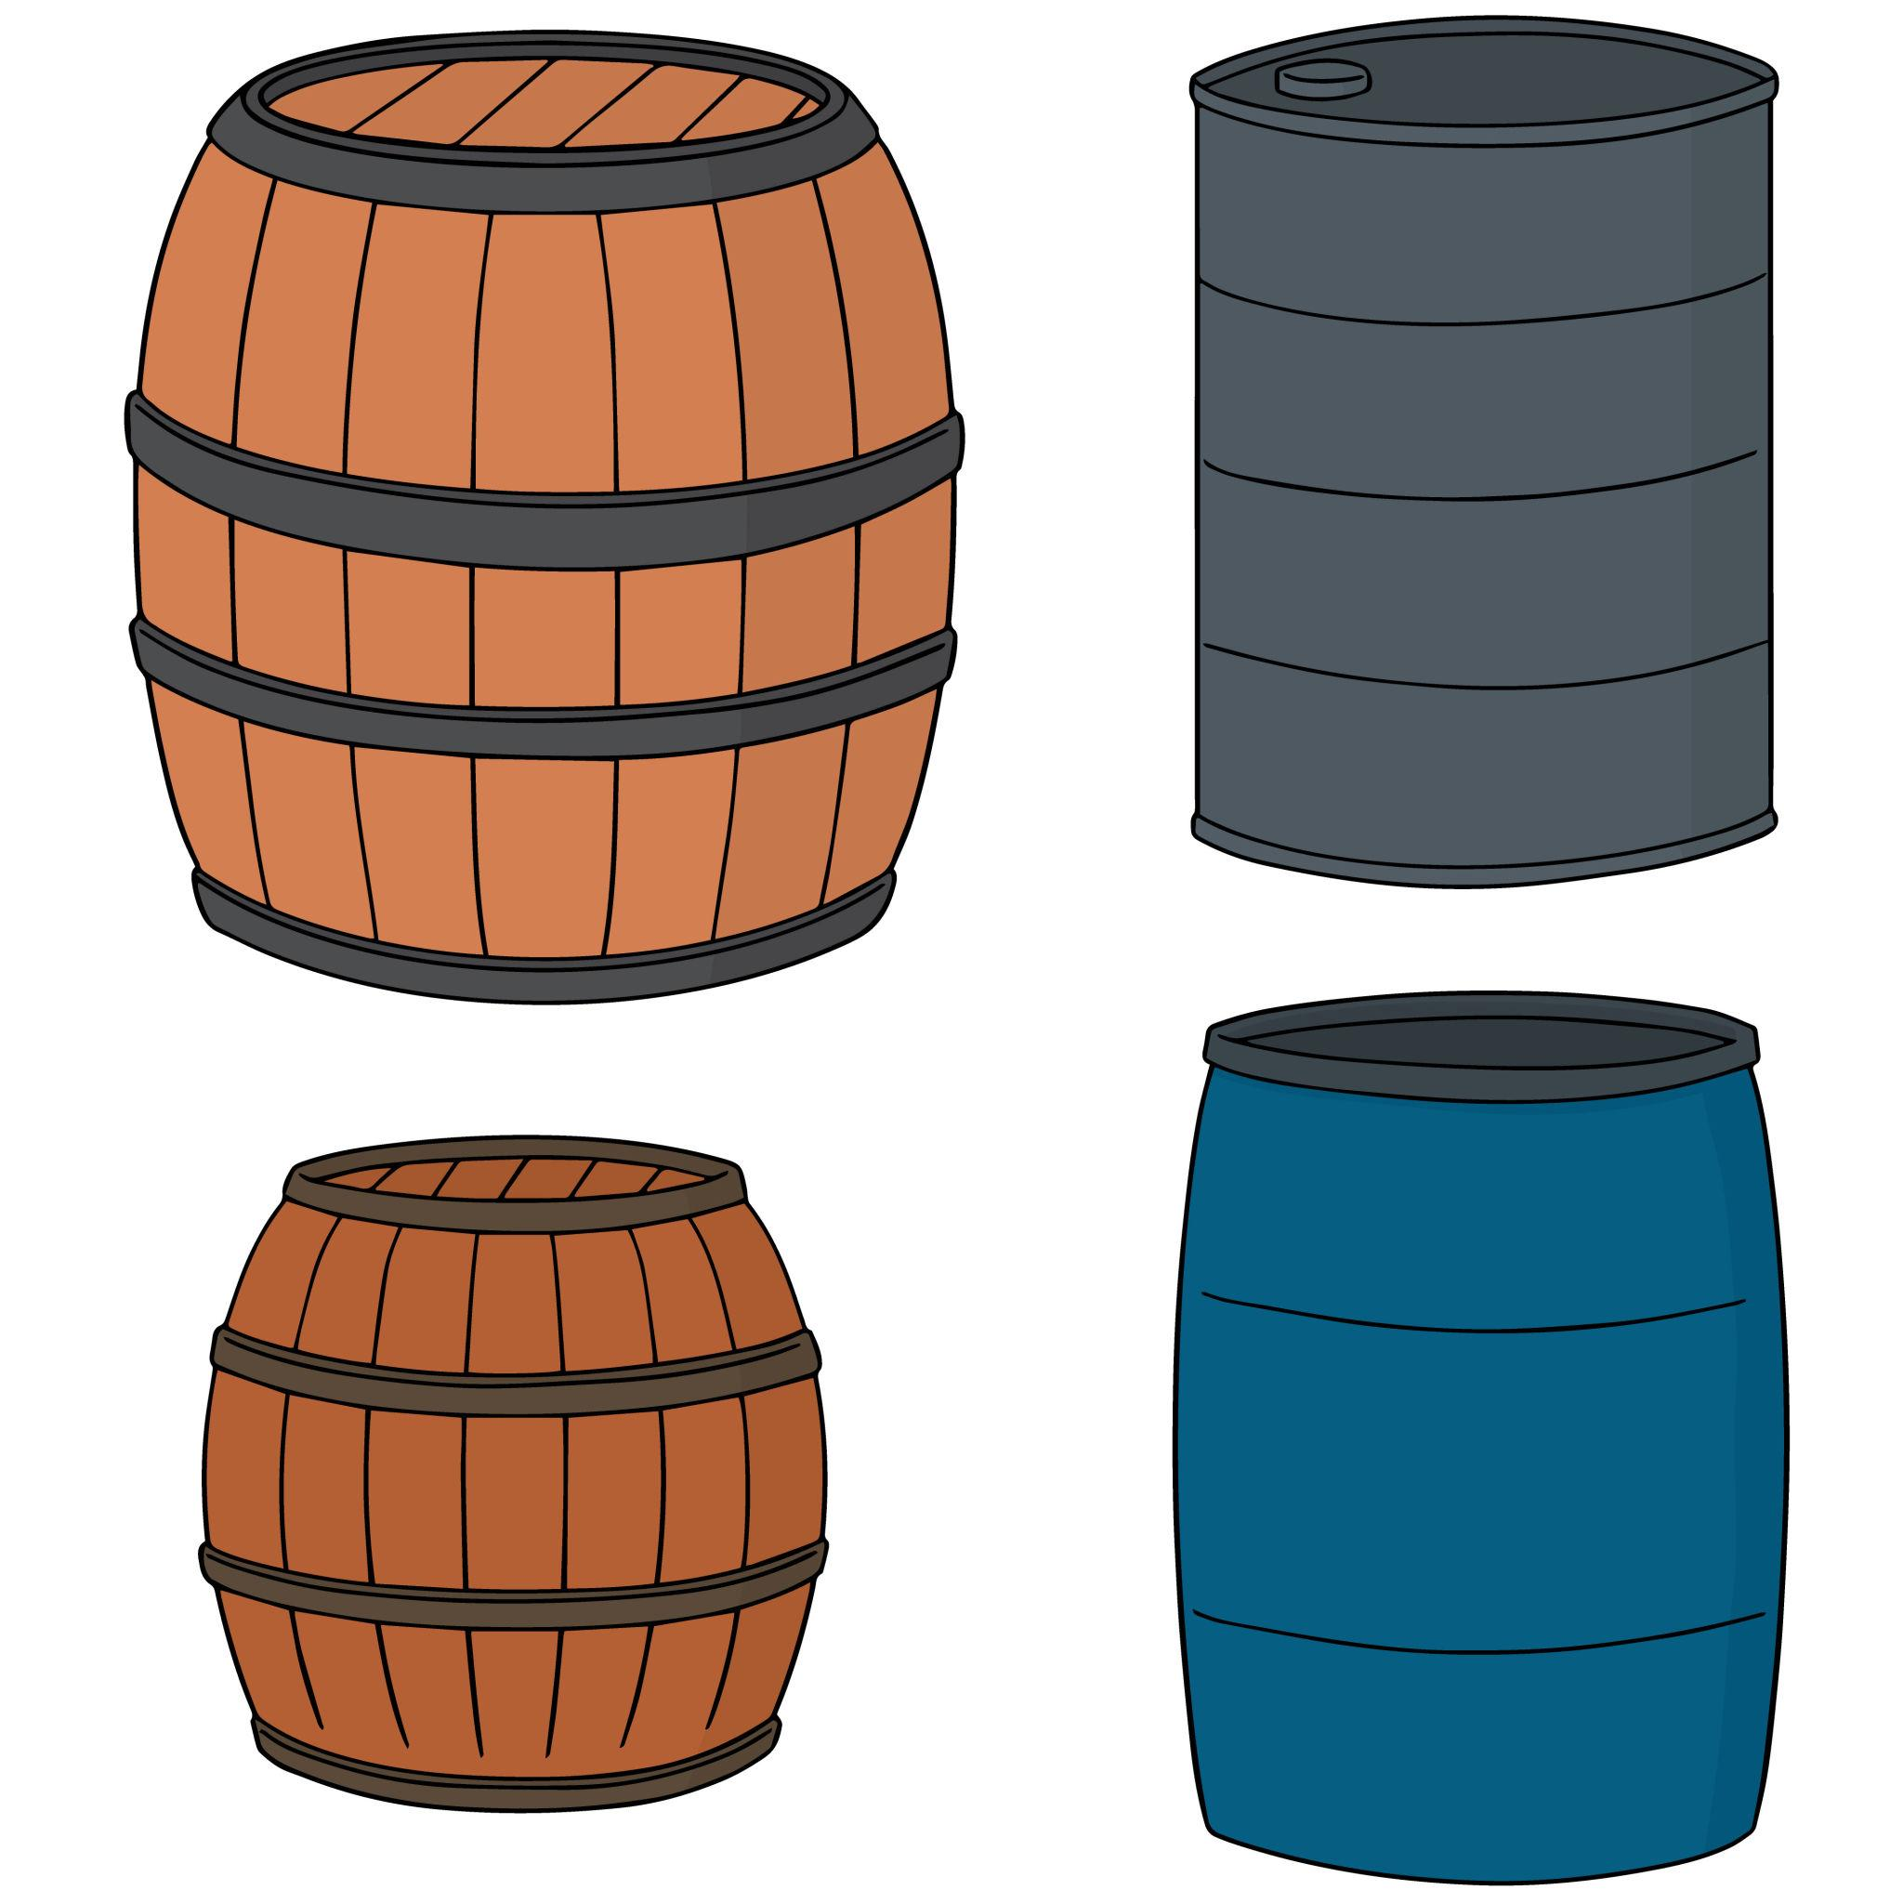
- Each barrel = arr[i]
- Weight = value
- Left side = sorted zone
- Right side = unsorted zone

🧾 The Code We’re Explaining
for (int i = 0; i < n - 1; i++)
{
int minIndex = i;

for (int j = i + 1; j < n; j++)
{
if (arr[j] < arr[minIndex])
{
minIndex = j;
}
}

int temp = arr[minIndex];
arr[minIndex] = arr[i];
arr[i] = temp;
}

🔍 Step-by-Step Graphical Mapping
🔹 1. Outer Loop → “Fix Position for Next Lightest Barrel”
for (int i = 0; i < n - 1; i++)
👉 Think:
- “I am choosing where the next lightest barrel should go”
📦 Example state:
[64, 25, 12, 22, 11]
↑
i = 0 (position to fill)
- Everything before i is sorted
- Everything from i onward is messy

🔹 2. Assume Current Barrel is Lightest
int minIndex = i;
👉 You say:
“For now, I assume this barrel is the lightest.”
📦
[64, 25, 12, 22, 11]
↑
minIndex = 0 (64 assumed smallest ❌)

🔹 3. Inner Loop → “Search for Lighter Barrel”
for (int j = i + 1; j < n; j++)
👉 You scan all remaining barrels:
📦 Scanning visually:
Compare 64 with 25 → smaller found ✅
Compare 25 with 12 → smaller found ✅
Compare 12 with 22 → no change
Compare 12 with 11 → smaller found ✅

🔹 4. Update Minimum
if (arr[j] < arr[minIndex])
{
minIndex = j;
}
👉 Every time you find a lighter barrel:
- You remember its position
📦 Final result of scan:
Smallest = 11
minIndex = 4

🔹 5. Swap → “Move Lightest Barrel to Correct Spot”
int temp = arr[minIndex];
arr[minIndex] = arr[i];
arr[i] = temp;
👉 Physically:
- Take the lightest barrel
- Swap it with the front unsorted position
📦 Before:
[64, 25, 12, 22, 11]
↑ ↑
i minIndex
📦 After:
[11, 25, 12, 22, 64]
✔ First position is now sorted

🔁 Full Process Visualization
Pass 1:
[64, 25, 12, 22, 11] → [11, 25, 12, 22, 64]
Pass 2:
[11 | 25, 12, 22, 64]
↓
pick 12
→ [11, 12, 25, 22, 64]
Pass 3:
[11, 12 | 25, 22, 64]
↓
pick 22
→ [11, 12, 22, 25, 64]

🧠 Mental Model (Tie Code → Action)
Code Line | What You Do Physically
i loop | Choose next position to fill
minIndex = i | Assume current barrel is lightest
j loop | Scan all remaining barrels
if check | Compare weights
minIndex = j | Update lightest found
Swap | Place lightest in correct position

⚡ Key Insight
- You don’t keep swapping repeatedly
- You:
  - Scan once
  - Pick minimum
  - Swap once
👉 That’s why:
- Fewer swaps than Bubble Sort
- But still O(n²) comparisons

📊 Complexity Reminder
T(n)=\frac{n(n-1)}{2}

💡 Developer Insight (Important)
In real systems:
- Selection sort is rarely used for large data
- But:
  - Great for learning
  - Useful when swap cost is high

If you want next:
- I can animate this step-by-step like a frame-by-frame simulation
- Or show how this compares visually with Bubble vs Insertion sort using same barrels

